**Outlook**

1. Open your calendar and expand My Calendars section. Right click My Calendars, Add Calendar, From Internet

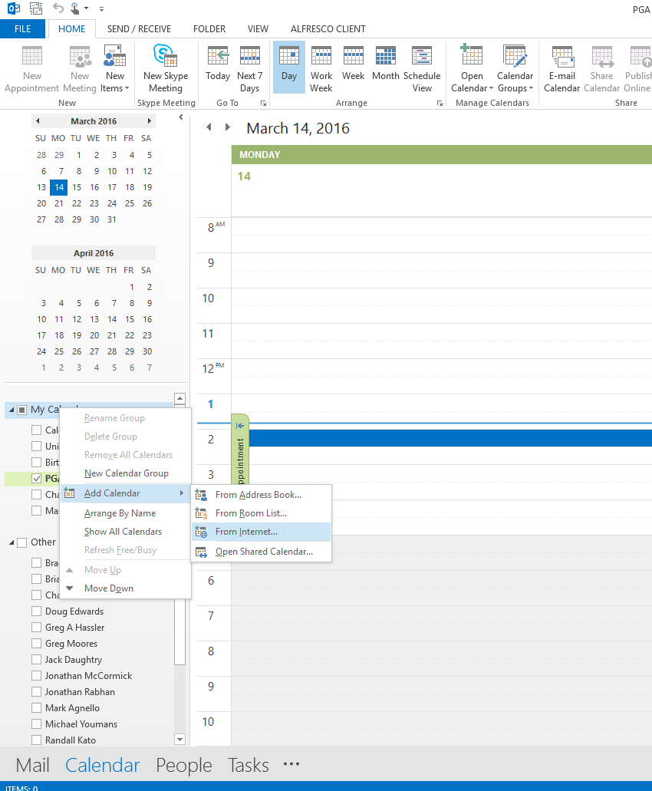

1. Type URL in field and click OK

iCalendar URLs

* PGA TOUR – http://pgatourical.pgatourhq.com
* Champions Tour – http://championstourical.pgatourhq.com
* Web.com Tour – <http://webical.pgatourhq.com>
* PGATOURLatinoamerica – <http://pgatourlaical.pgatourhq.com>
* Mackenzie Tour – http://pgatourcanadaical.pgatourhq.com
* PGA TOUR China – <http://pgatourchinaical.pgatourhq.com>

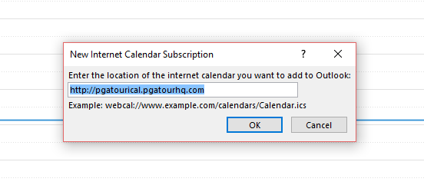

1. Click Yes to add the calendar to Outlook.
2. You’ll see the calendar has been added under My Calendars or Other Calendars.

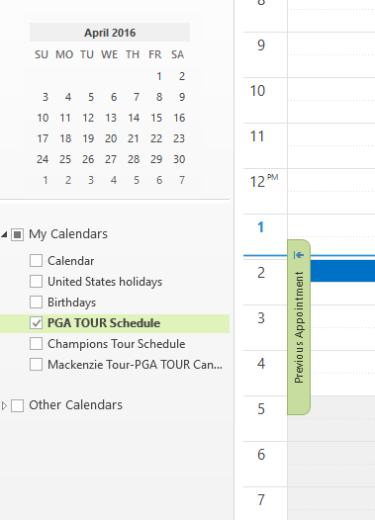

**Lotus Notes**

1. Open your calendar and expand the Show Calendars section. Select Add a Calendar.

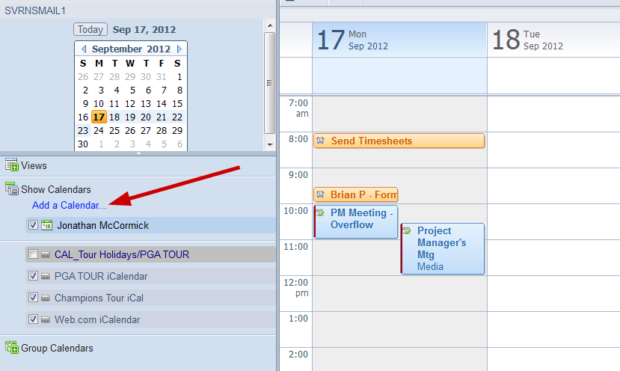

1. You’ll then be presented with the following screen (see screenshot below). Under Add, select iCalendar feed and select A public calendar. Under Label enter in what you'd like to name this calendar (e.g. PGA TOUR Schedule iCal), under URL enter the URL of the iCal feed. See below for the list of feeds available.

iCalendar URLs

* PGA TOUR - pgatourical.pgatourhq.com
* Champions Tour - championstourical.pgatourhq.com
* Web.com Tour - webical.pgatourhq.com
* PGATOURLatinoamerica – pgatourlaical.pgatourhq.com
* PGA TOUR Canada – pgatourcanadaical.pgatourhq.com

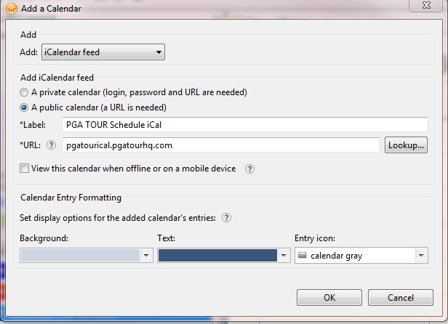

1. You’ll then see that the calendar has been added to the list of calendars on the left hand side under Show Calendars. Check the calendar which you’d like to appear in your Lotus Notes and you’ll see the Tournaments appear on their competition dates.

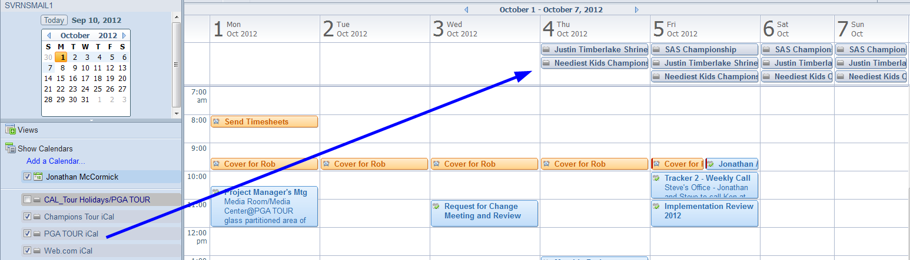

**iPhone**

|  |  |  |
| --- | --- | --- |
| 1. Select Settings | 1. Select Mail, Contacts, Calendars | 1. Select Add Account |

Continued on next page...

|  |  |  |
| --- | --- | --- |
| 1. Select Other | 1. Select Add Subscribed Calendar | 1. Server: For PGA TOUR enter pgatourical.pgatourhq.com, Champions Tour enter championstourical.pgatourhq.com, Web.com enter webical.pgatourhq.com and for PGA TOURLatinoamerica enter pgatourlaical.pgatourhq.com. Enter a description for the iCal (e.g. PGA TOUR Schedule – iCal) |